Nature Retreat XXVII

The Humpback Whale

Sermon Outline:

Psalm 96:1—A New Song

I. At Dusk In The Bermuda Reefs

II. Big Breakthrough—German U-boats in WWII

III. Katy Payne

IV. Some Amazing Discoveries

V. Wrapping Things Up

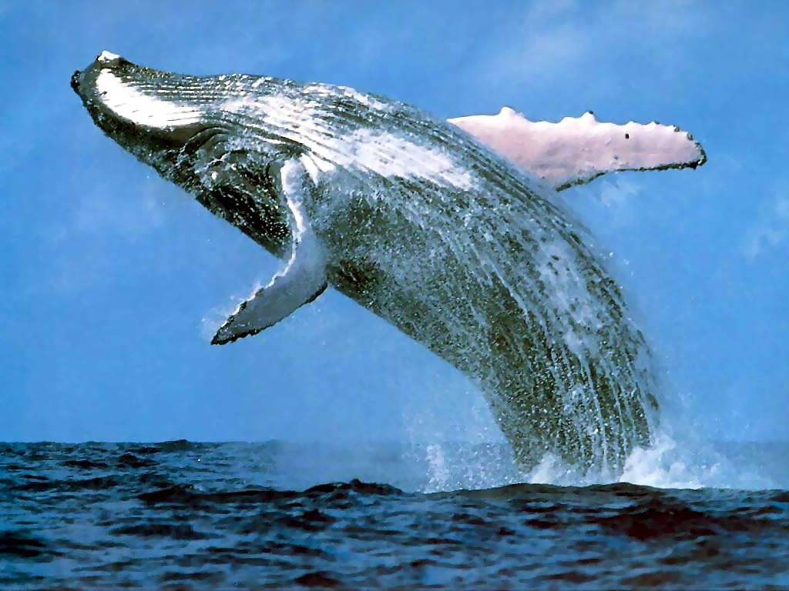

A
New
Song

15 September 2018

Nature Retreat XXVII

Water Of Life

The Humpback Whale

Order of Service:

Opening Hymn: Let All things Now Living, CW 260

Reading: Romans 8:19-22

Children: “The Humpback Whale Song

Sermon Hymn: Sing A New Song, CW 245

Sermonette: Psalm 96:1

Sing A New Song

The Lord’s Prayer

Closing Hymn: God Be With You, CW 327

Nature Retreat XXVII

We live in an area of intense natural beauty. And it was 26 years ago that Christine and I hit on the idea of sharing our section of God’s Country over an open Bible with Christian friends who had a love for nature and the Word of God.

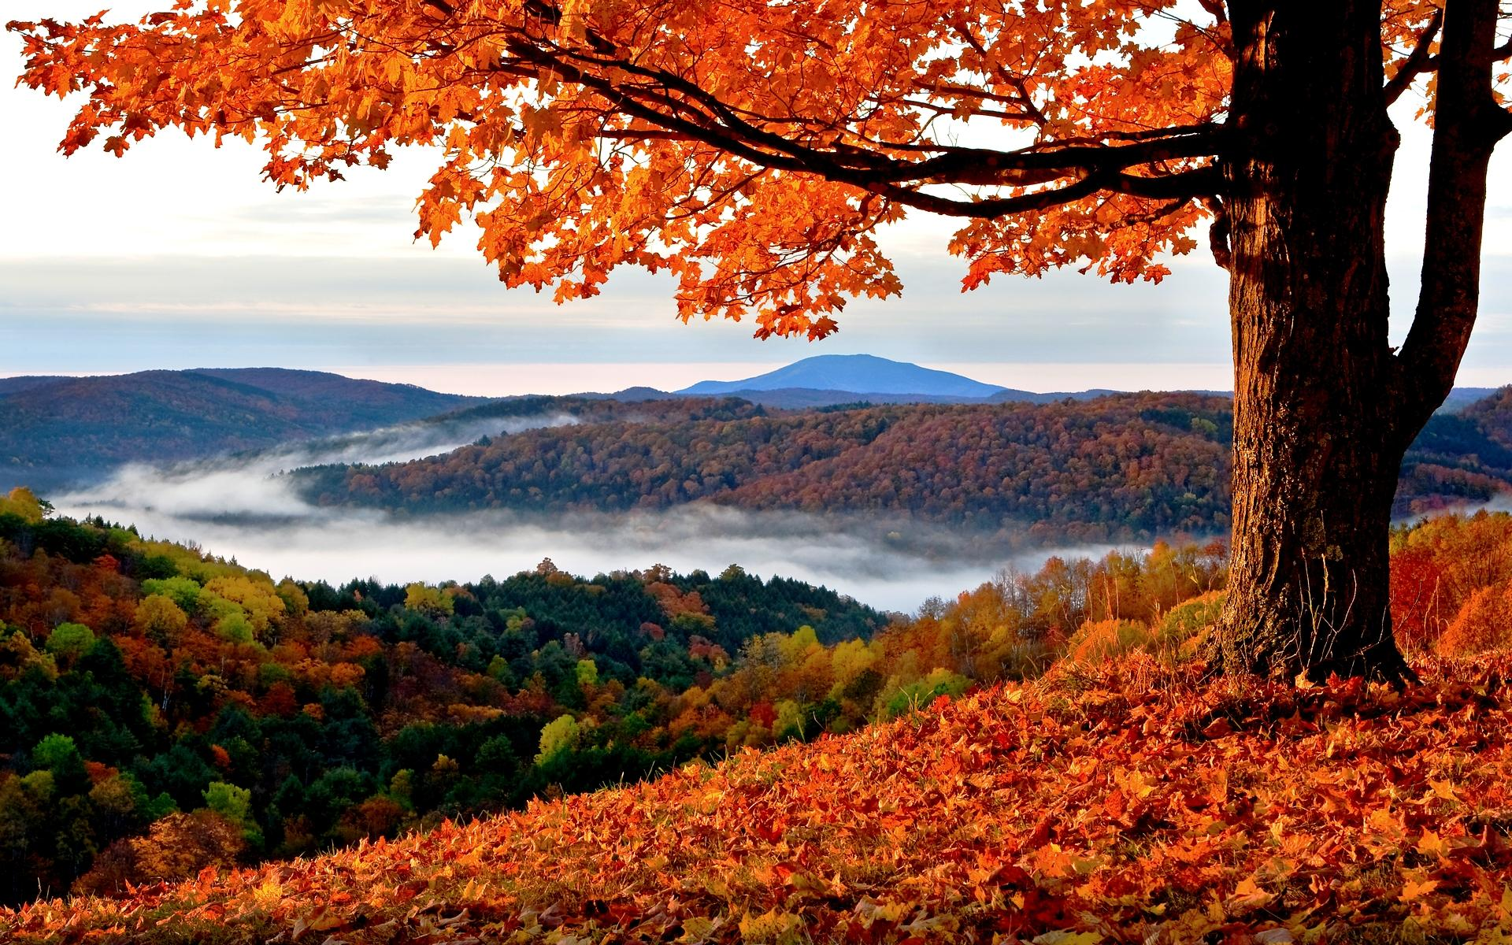

Looking back over the years, there are so many pleasant memories we have of our Nature Retreats. Old friendships have been renewed and new friendships have been formed. And we have been blessed with good weather every single time.

Over the years we have had contact with the hills and the clouds; with the Monarch Butterfly and the Scarlet Worm; with the Sun, Moon, and Stars; with Eagles and the Great Horned Owl; with the Great Pyramid of Egypt; with the Loon and the Arctic Tern; with Ants and Snowflakes; with the Sea and the Northern Lights. The Lord God’s creation, speaking to us from the pages of the Volume of Nature. And from the light found in the Volume of Holy Scripture.

